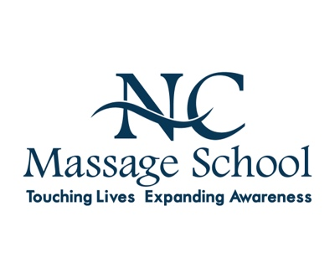

Name:
Email:

1. Please describe your purpose for enrolling in our training program and what you hope to gain from it. We would like to know about your personal and professional goals and whether you intend to pursue a career in Massage Therapy in the future.

2. Provide details about your academic background, including schools attended, graduation dates, GPA and whether you received a certificate or degree.

3. Please provide details about any training or prior experience you may have had in massage therapy or other health care practices, whether through workshops, formal training, or apprenticeships.

4. Have you received professional massage therapy in the past? If so, please list the number of sessions you have had within the last two years.

5. If accepted into the program, please describe how you plan to finance your tuition and training expenses.

6. Have you ever been convicted of a crime or been on probation for a crime (other than minor traffic offenses)? If so, please provide details, including dates.

7. Have you been treated by a physician within the last five years? If yes, please explain.

8. Do you have any learning disabilities or needs for special instruction/accommodations?
If so, please explain and list any diagnoses given by a medical professional.

9. Is English your first language? If not, do you speak, read and write fluent English?

10. How did you learn about NC Massage School, Inc., and why did you choose our school for your training?

